How to print from the Pearson Website:
Step 1: Sign-in to www.pearsonrealize.com
Step 2: Click on the middle orange tab – Classes
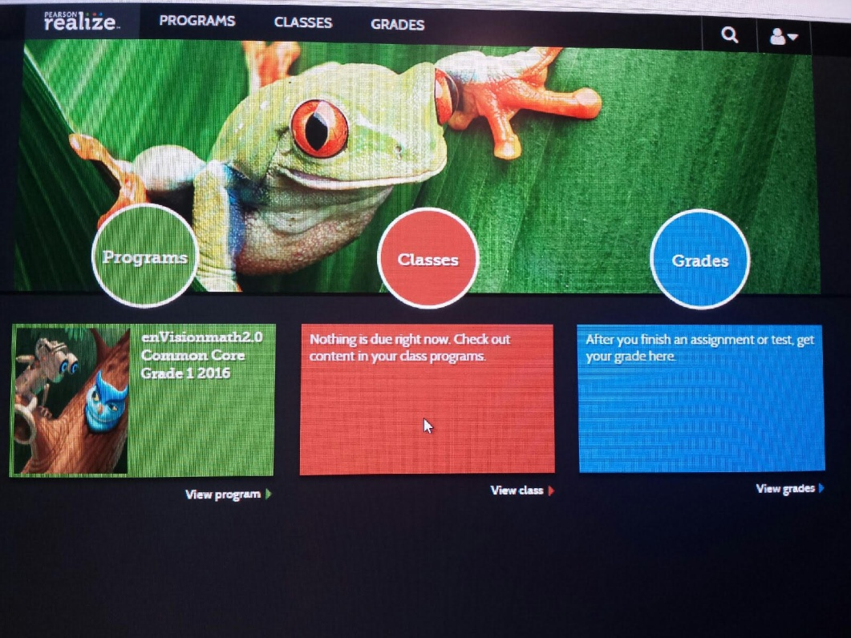
Step 3: On the right hand side of the page, click on “Grade 1 ACTIVe-book Vol 1
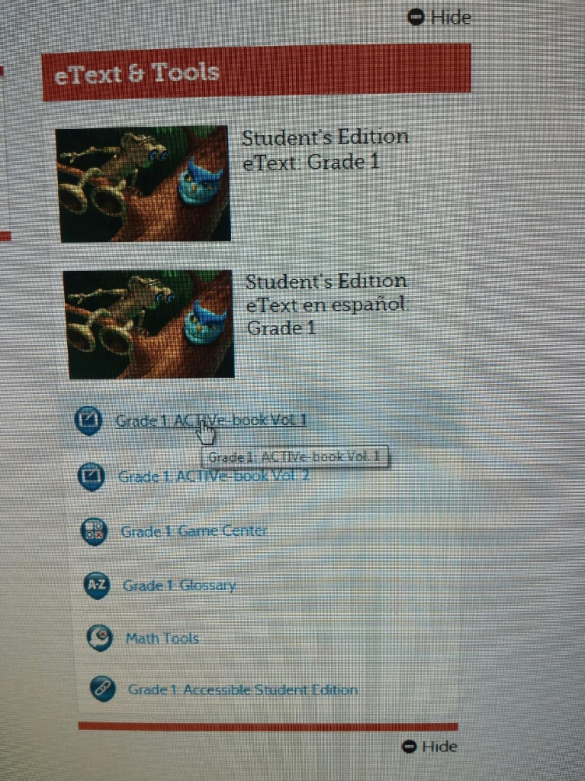

Step 4: Click on the lesson that you want to view at the top of the screen. In this example, I am clicking on 1-9
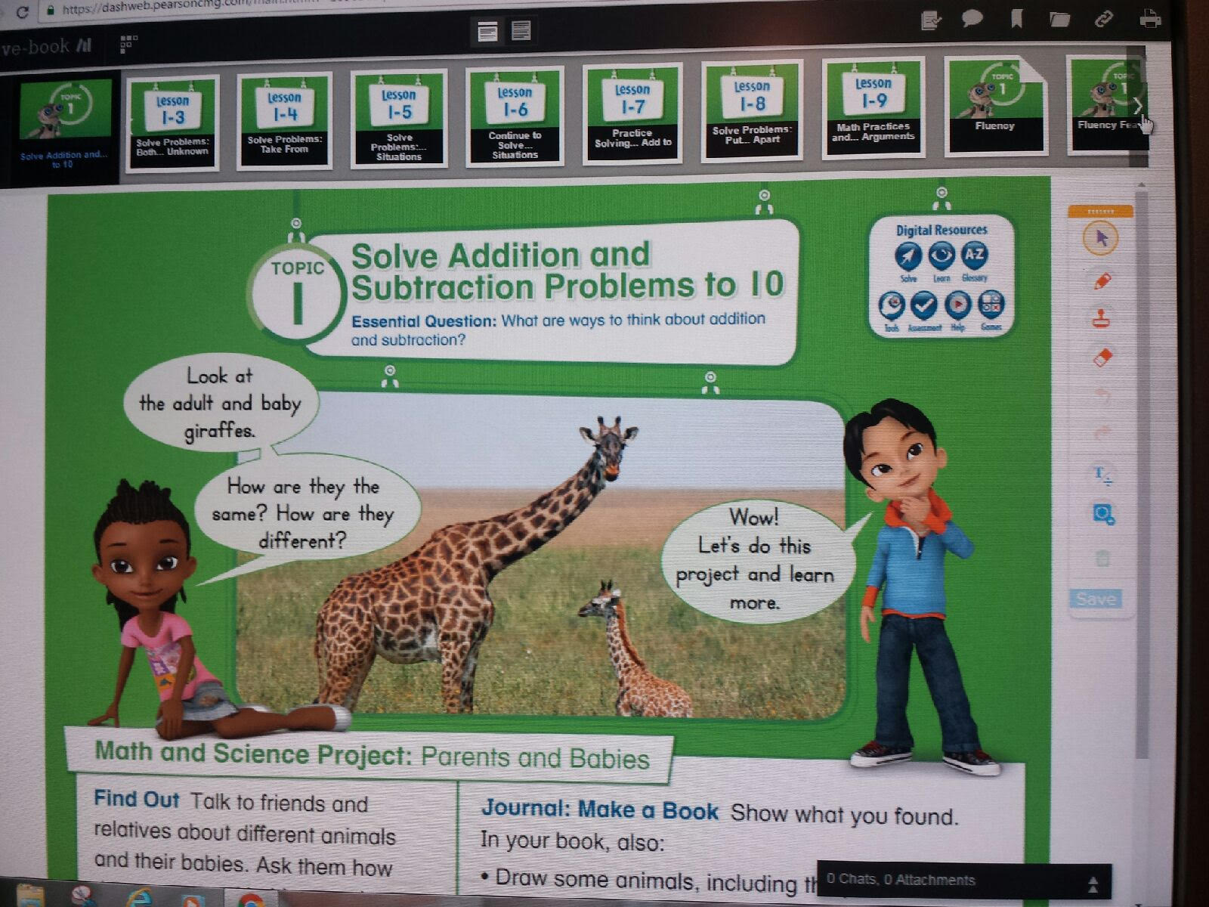
Step 5: Click on what you want to print (I clicked on 1-9 homework, page 1)
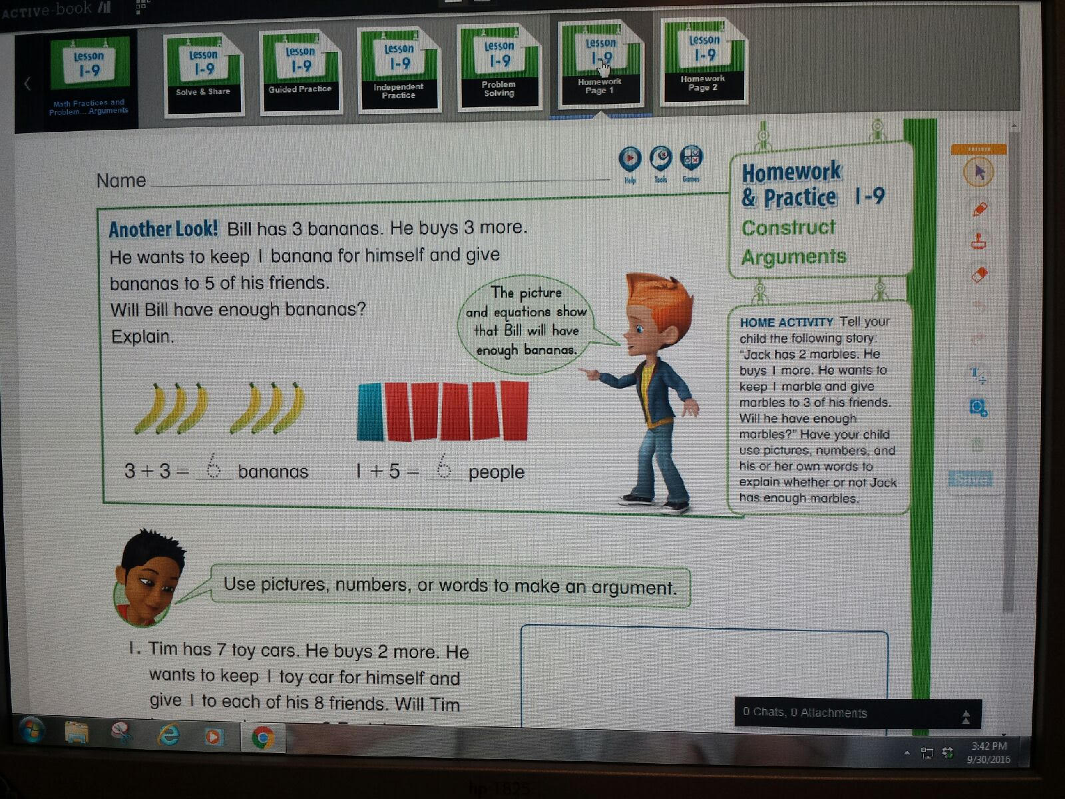

Step 6: Click on the printer icon on the top right corner of your screen and follow your printer’s instructions.
