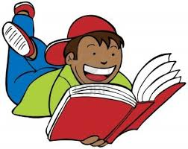Reading Response Menu

After reading for 20 minutes pick one of the books you read and write the date, title, author, and response number in your Reading Log Notebook. You will pick a question from the list below on MONDAYS and FRIDAYS to answer and help you grow as a reader. Write 3-4 sentences and draw an illustration to respond to the question on the next clean page of your notebook.

FICTION
- Who is your favorite character in the story? Tell why!
- Did you learn any lessons from the story? Tell about them.
- Is there anything you did not understand about the story?
- Was the story fiction or nonfiction? How can you tell?
- To whom would you recommend this book? Why?
- Tell about the beginning of the story.
- Tell about the middle of the story.
- Tell about the end of the story.
- Was there a funny part in the story? Tell about it.
10. Is this book like any other book you have read?

NONFICTION

11. What are three new facts that you learned?
12. What did the photographs in the book teach you?
13. What did this book remind you of? Why?
14. What was your favorite part of the book? Why?
15. Write down four new words and their meaning that you learned.
16. Did you like this book? Why or Why not?

